

AHU CONTROLLER TEST DATA SHEET

|  |  |  |
| --- | --- | --- |
| P/N: 413-8005-1-47 |  | Date: 03/03/2019 |
| DRIVER S/N: 622 |  | Time: 17:22 |
| UA: 47 |  | Tested by: GUY |
| Hardware Rev: BLDC_60A_V6 |  | Approved by: GUY |
| Software Rev: 5.3.8d |  |  |
| Parameters rev.: AHU-LEFT version 0.2 |  |  |
| Tester Software Version: V1.2s |  |  |
| DSP BOARD S/N: LA1904-0066 |  |  |
| POWER BOARD S/N: LA1904-0052 |  |  |
|  |  |  |
|  |  |  |
|  |  |  |
|  |  |  |
|  |  |  |
|  | Equipments Used |  |
|  |  |  |
| Equipments |  |  |
|  |  |  |
| Power Supply |  |  |
| Digital Multimeter |  |  |
| CAN Interface |  |  |
| BLDC Tester |  |  |
| PC |  |  |
| Heater |  |  |
| RS-232 Interface |  |  |
| Current Meter |  |  |

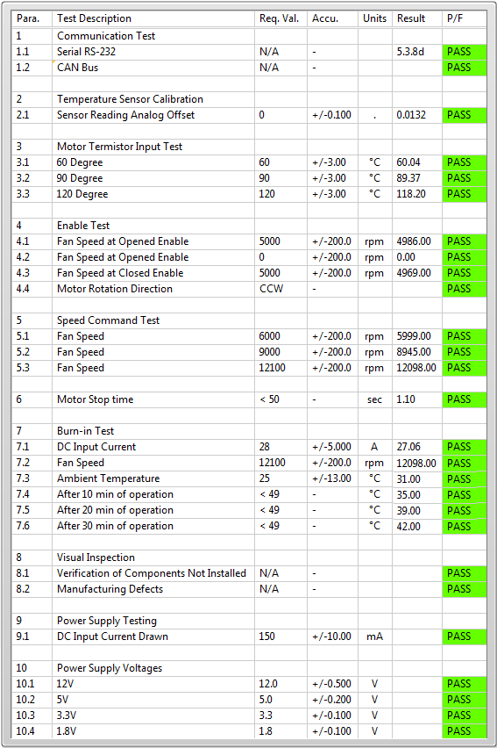

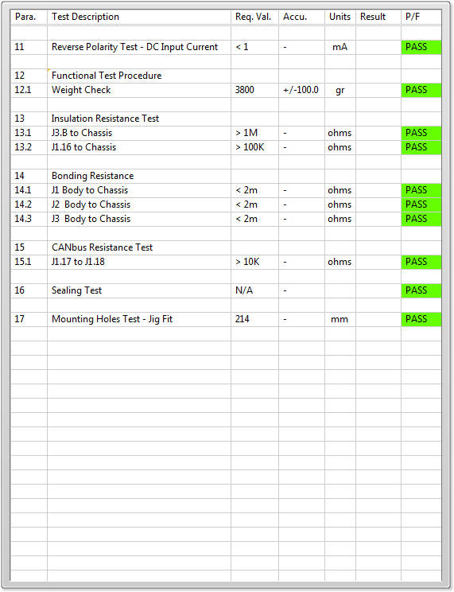

General result:

Test-Operator:____ GUY_________ Q.A.:__________________________